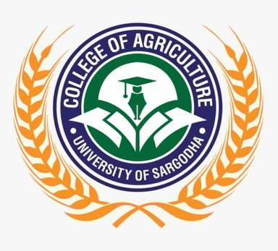  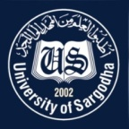 | Faculty Positions on Visiting Basis
College of Agriculture
University of Sargodha
Applications for the following positions are invited from Pakistani nationals for Spring Semester-2021.
Teaching Faculty

Sr.# | Positions | No. of Posts | Nature of Post | Eligibility Criteria
1. | Visiting Assistant Professor / Lecturers  - Entomology  - Soil Science  - Agricultural Economics  - Agricultural Extension  - Horticulture | 02  02  04  02  01 | Visiting Faculty  (Open merit, for Spring semester 2021). | Qualification:-  - Ph.D in relevant field for Assistant Professor  - M.Sc. (Hons) / M.Phil in relevant field for Lecturer
NOTE |  |  | General Information
- As per university policy, the institute/department reserves the right not to consider any application or fill any post without giving any reason.
- Candidates are required to submit complete C.V and attested copies of testimonials along with
duly filled application form in the concerned office.
- Prescribed application form may be downloaded from university website
(https://www .uos.edu .pk/adminForms)
- Applications complete in all respects should reach in the College on or before 22-02-2021 (04:00 PM).
- Interview of the short-listed candidates will be conducted on 23-02-2021 (at 11:00 AM) in the office of Principal, College of Agriculture, University of Sargodha.
- Only short listed candidates will be called for interview.
- The applicants having provisional transcript will not be eligible for the visiting faculty
- Applications received after due date will not be entertained.
- Candidates with relevant experience will be preferred.
- Seats can be increased or decreased according to the requirement of department.
- Applications address to Concerned Departmental Chairperson / Incharge, College of Agriculture, University of Sargodha.
- Online applications will not be accepted.

Prof. Dr. Muhammad Ather Nadeem
Principal
College of Agriculture
University of Sargodha

